|  |  |
| --- | --- |
| **Name of the Team :** | **HIDEN GEMS** |
| **Team ID :** | **662024-MI044** |
| **Guide Name :** | **Ms. Sahithya** |
| **Department :** | **Computer science and engineering (Ai&ml)** |
| **Title of the Mini Project :** | **Interview experience** |
| **Date :** | **02-03-2023** |
|  |  |

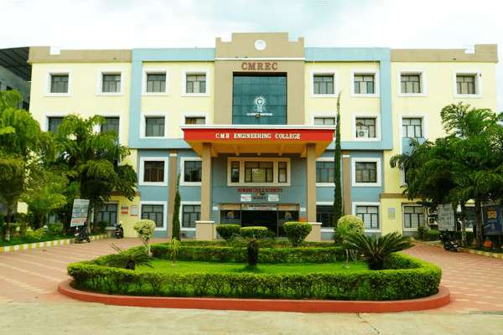

**Name of the team : hiden gems**

**Guide :** Ms.Sahiathya

**Department :** COMPUTER SCIENCE AND ENGINEERING(AI&ML)

|  |  |
| --- | --- |
| **Title of the thesis** | : interview experience |

**ABSTRACT**

Your success in a job interview depends a great deal on how you prepare for it. Interview preparation primarily involves researching the job and the company and thoughtfully considering your answers to the interview questions. The type of question an Interviewer may ask differs from person to person, the questions may be related to technical skills, personal, tricky, random general topics, etc. Hence, we are required to prepare for the best. In addition to pre-interview preparation, there are certain aspects you are required to prepare for during and after the interview.

This could be easily accomplished using this portal; anyone can use it to post questions, answer them, and review them. Anything related to interview questions, coding questions, important topics, preparation tips, and so on can be posted. Simply reading it would greatly aid the interview candidate's preparation.

**OBJECTIVES:**

* The main objective of our project is to compile all kinds of interview questions asked by interviewers from various companies.
* We have found out that most of the students who are preparing for campus placements panic on How and what to prepare for that specific company interview.
* Through this portal/site we would like to create a self-help site where fellow students can help their peers to prepare for interview.

|  |  |
| --- | --- |
| |  | | --- | | 1 | |

**CONCLUSION:**

### Our project is a reliable and self developing site, where the only inputs are from the users in the form of questions and answers. Generally, preparing for an interview might confuse few people and I would suggest this site could be every helpful during this time. We made an all0in-one site where all the essential and required questions related to interview preparation, technical questions, aptitude questions, general questions etc can be posted as well as answered. This portal can act as a compilation of all the queries an aspirant may get while preparing for an interview.

**FUTURE WORK:**

Notifications:

Further, notifications related to company placements, dates, internship, company drive updates etc can be posted.

Spaces / Teams:

With-in the website users with same interest can form their own community or team space. Linking to other social accounts:

Users can be further be linked with their other social accounts like linkedin, facebook, twitter etc.

Guide Comments:

**Student Names : Guide**

**208R1A66G4-SAI CHANDRA GOUD**

**208R1A66E6-NAVEEN**

**208R1A66F1-VINAY KUMAR**

**208R1A66H8-PAVAN KUMAR**